Block 1: Activating the console and printing the heading of the game.

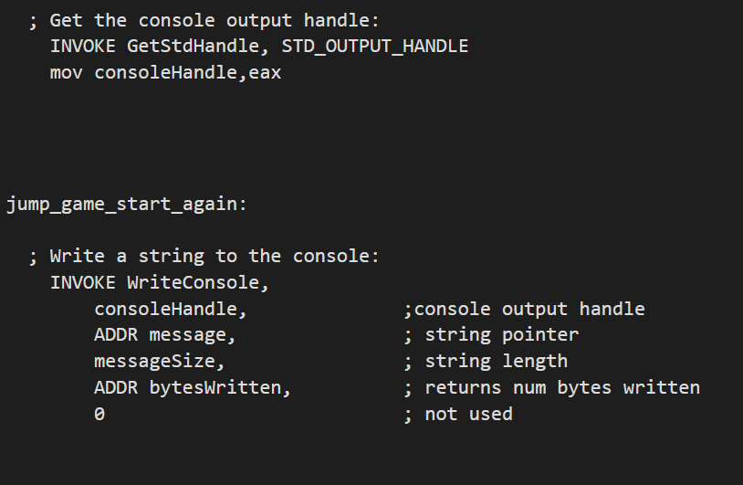

Block 2: Calling Randomize function to get the length of the word and finding the word of the desired length.

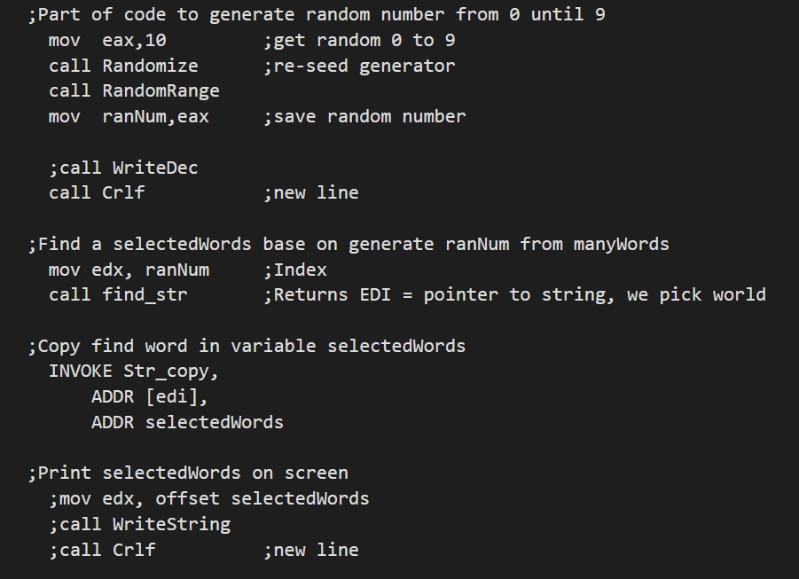

Block 3: Printing an array of dash of the evaluated length and initializing game lives.

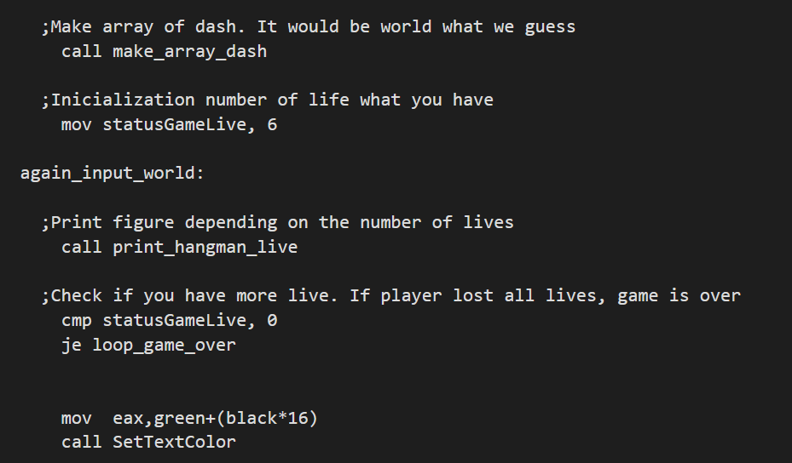

Block 4: Getting a character from the user and checking the basic checks. (ESC, SPACE, Letter Check)

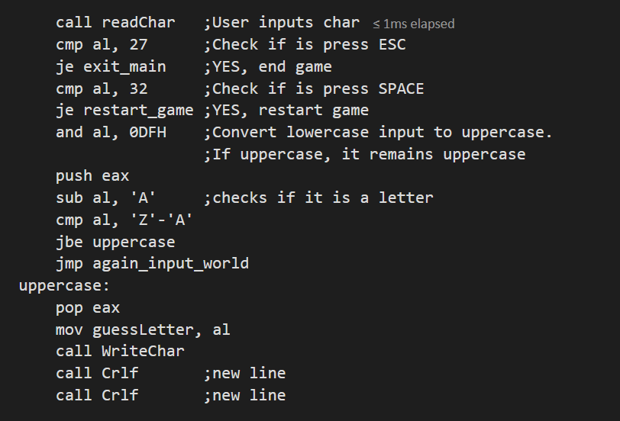

Block 5: Conditional Check to check if the letter is not being repeated or if the guessed letter doesn’t match any of the letters in the string.

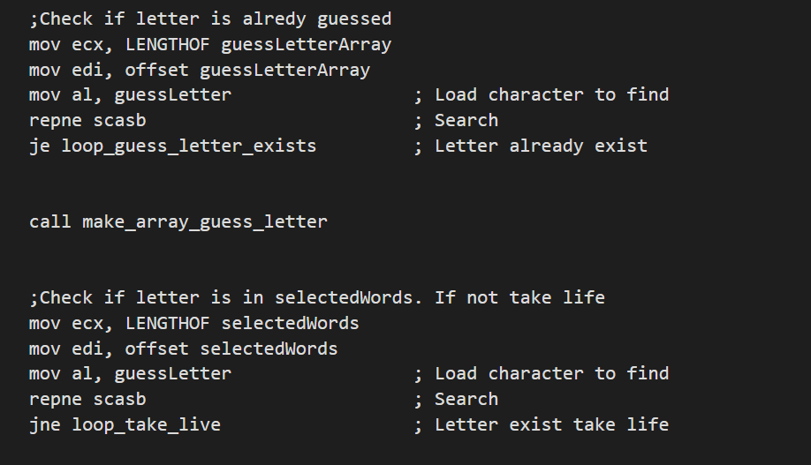

Block 6: Searching the guessed word from the whole string and replacing the dash with the letter.

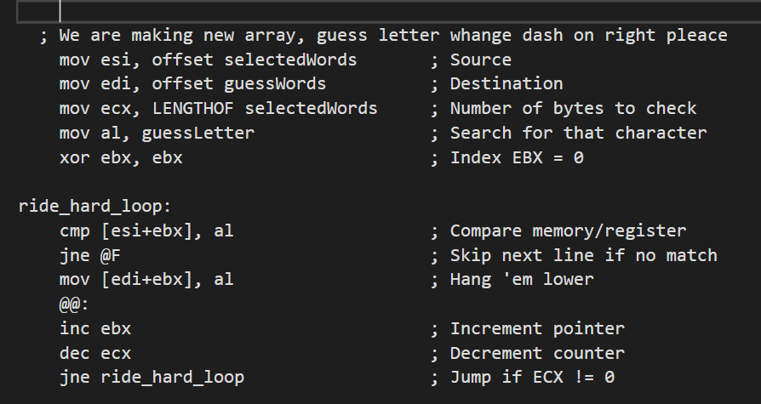

Block 7:

Checking if the there are letters remaining to be guessed.

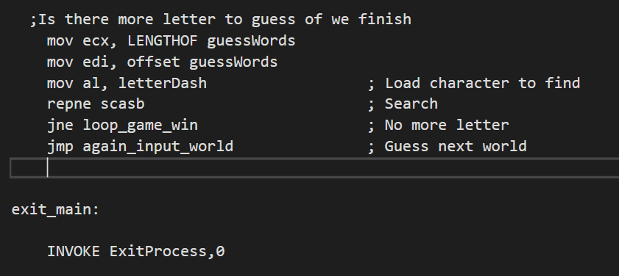

**Definition of Labels**

1. **Guess Letter Label**

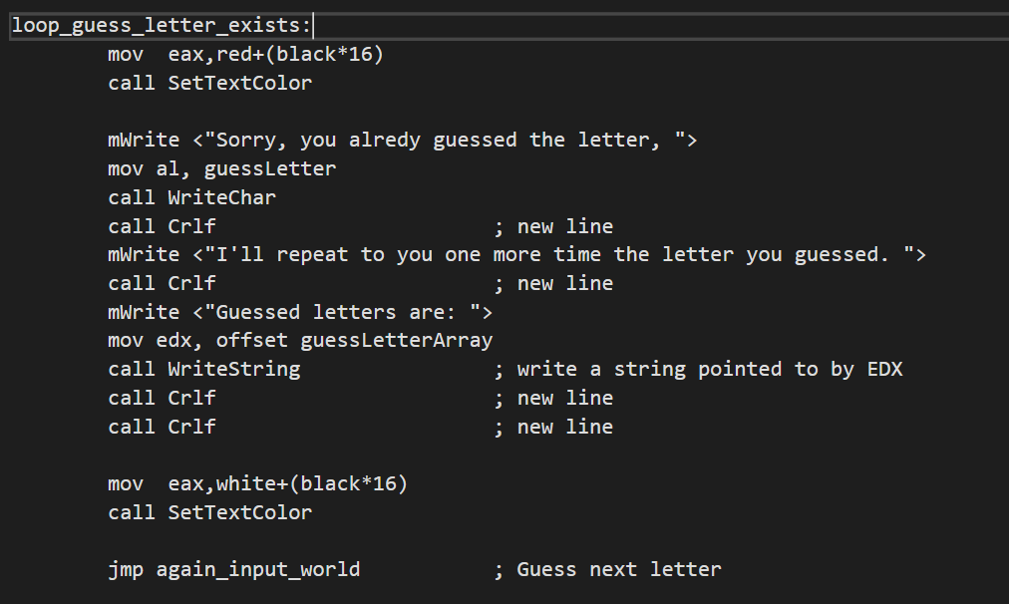

1. **Take Life Label**

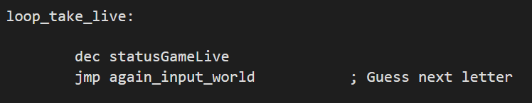

**Variables Used**

